ASSIGNMENT 1 (CO1)
Design, Implement and Validate a Reliable Billing Program
for a Rural Electricity Co-operative
Programme: B. Tech Biotechnology
Course Code: CSA0232
Course Name: C Programming
Submitted by: MAVES TEFFANY
Register Number: 192522056
Faculty: Dr . NATTAR KANNAN
Slot: C
GitHub Repository: https://github.com/192522056simats-commits/CSA0203-SLOTC.git

TASK 1

Introduction
Grama Jyothi Rural Electricity Co-operative provides electricity to approximately 4,000 households every month. The billing system calculates electricity consumption using previous and current meter readings. Based on the units consumed, the system calculates the energy charge and fixed charge to generate the final electricity bill.
The program must produce accurate bills, handle meter rollover conditions and avoid calculation errors. It should also support future expansion from village-level billing to district-level billing.
A. Input Data
Input | Description | Justification
Previous Reading | Electricity meter reading from the previous month | Required to calculate consumption.
Current Reading | Latest electricity meter reading | Used to determine the units consumed.
Household Number | Unique identification number of each household | Helps identify and maintain individual bills.
Category | Type of household or electricity connection | Helps identify the applicable billing category and tariff.
B. Output Data
Output | Description | Justification
Units Consumed | Difference between current and previous readings | Determines electricity usage.
Energy Charge | Amount calculated based on consumption slabs | Calculates the electricity usage cost.
Fixed Charge | Fixed amount added to every bill | Covers basic service charges.
Total Bill | Sum of energy charge and fixed charge | Displays the final amount payable.

Values That Should Be Constants
Constants are values that remain unchanged during program execution. They should be defined in one place to make tariff revisions easier.
Constant | Value | Purpose
SLAB1_UNITS | 100 | First 100 units are free.
SLAB2_UNITS | 200 | Defines the second consumption slab.
RATE1 | Rs. 0 | Rate for the first 100 units.
RATE2 | Rs. 2.25 | Rate for units 101–200.
RATE3 | Rs. 4.50 | Rate for units above 200.
FIXED_CHARGE | Rs. 50 | Fixed charge for every household.
METER_MAX | 65535 | Maximum value of a 16-bit unsigned meter register.
These constants prevent repeated tariff values throughout the program and make future changes easier.

Values That Can Be Negative, Fractional or Very Large
A. Negative Values
- Meter readings should never be negative.
- Electricity consumption should never be negative.
- A negative consumption value may occur if meter rollover is not handled correctly.
- The final bill must never be negative.
B. Fractional Values
- Energy charges may contain fractional rupees.
- For example, Rs. 2.25 per unit contains 25 paise.
- Therefore, money should be calculated accurately using integer paise instead of floating-point rupees.
C. Very Large Values
- Household numbers may increase as the system expands.
- Total electricity consumption and total billing amounts may become very large when processing 800,000 households.
- Therefore, suitable integer data types should be selected to avoid overflow.

Rules Every Correct Bill Must Satisfy
- Previous and current meter readings must be valid and within the meter's permitted range.
- Electricity consumption must be calculated correctly.
- Meter rollover from 65535 to 0 must be handled without producing negative consumption.
- The first 100 units must be free.
- Units from 101 to 200 must be charged at Rs. 2.25 per unit.
- Units above 200 must be charged at Rs. 4.50 per unit.
- The fixed charge must be added to the energy charge.
- The final bill must never be negative.
- The total bill must equal the energy charge plus the fixed charge.
- All monetary calculations must be accurate to the nearest paisa.
Formula: Total Bill = Energy Charge + Fixed Charge

Assumptions
- Every household has a unique household number.
- Each household has one electricity meter.
- The meter uses a 16-bit unsigned register with a maximum reading of 65535.
- The meter reading is recorded once every month.
- The tariff rates remain the same during one program execution.
- The first 100 units are free, the next 100 units cost Rs. 2.25 per unit, and units above 200 cost Rs. 4.50 per unit.
- A fixed charge of Rs. 50 is applied to every household.
- Meter rollover is considered when the current reading is lower than the previous reading, assuming only one rollover occurred between readings.

Conclusion
The Grama Jyothi electricity billing system requires proper identification of inputs, outputs, constants and calculation rules. Integer representation is suitable for meter readings, while monetary values should be handled accurately using paise. Meter rollover must also be considered to prevent negative consumption. This design provides a reliable foundation for implementing the billing program and supports future expansion to taluk and district levels.
TASK 2

Introduction
Choosing the correct data types is important for developing a reliable electricity billing system. Each data item must be stored using a suitable C data type based on its size, range and purpose.
The system processes electricity readings, household numbers, energy charges and total bills. Therefore, suitable data types must be selected to avoid overflow, negative values and precision errors.

Source code
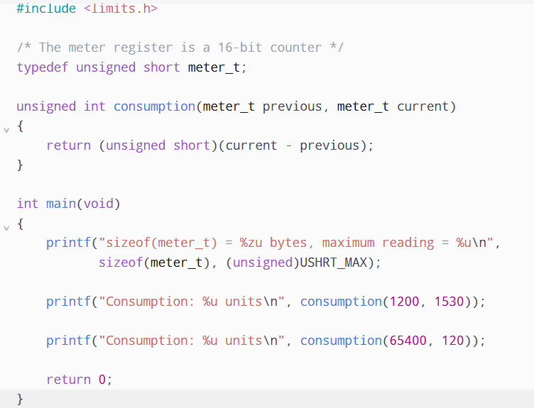

Output
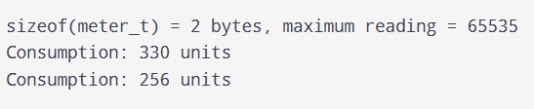

Conclusion
Selecting suitable data types is essential for developing an accurate electricity billing system. unsigned short is suitable for storing 16-bit meter readings, while unsigned int can store electricity consumption. Integer paise should be used instead of floating-point rupees to avoid rounding errors. For large-scale district billing, long long is recommended for accumulating the total amount. These choices help maintain accuracy and prevent overflow problems.

TASK 3
Introduction
Constants are fixed values that cannot be changed during program execution. In the Grama Jyothi electricity billing system, tariff rates, slab limits and fixed charges should be defined as constants. Using constants avoids writing the same values repeatedly throughout the program. If the electricity tariff changes, we can update it in one place without modifying the entire program.

Define Tariff Values Using Constants
The following constants are used in the electricity billing system.
Constant | Value | Purpose
SLAB1_UNITS | 100 | First 100 units are free.
SLAB2_UNITS | 200 | Defines the second slab limit.
RATE1_PAISE | 0 | First slab rate.
RATE2_PAISE | 225 | Rs. 2.25 per unit.
RATE3_PAISE | 450 | Rs. 4.50 per unit.
FIXED_CHARGE_PAISE | 5000 | Rs. 50 fixed charge.
These values are defined using #define so that tariff revisions can be performed easily.

Difference Between #define, const and enum
C provides different ways to define constants.
A. #define
- It is a preprocessor directive.
- It replaces the constant name with its value before compilation.
- It does not require separate memory storage.
- It is suitable for fixed tariff values and slab limits.
EXAMPLE
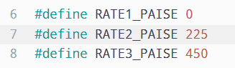

B. const Variable
- It declares a variable whose value cannot be modified through that identifier.
- It has a specific data type and It supports type checking.
- It can be inspected using a debugger.
C. enum
- It defines a group of named integer constants.
- It is useful for representing categories and fixed options.
- It improves program readability.

Source code
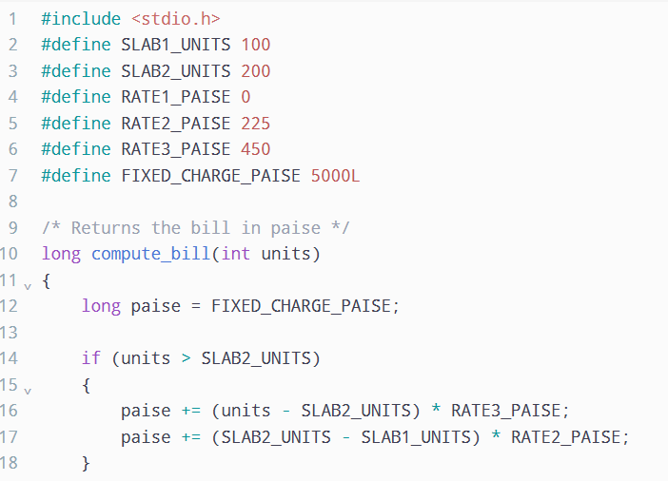
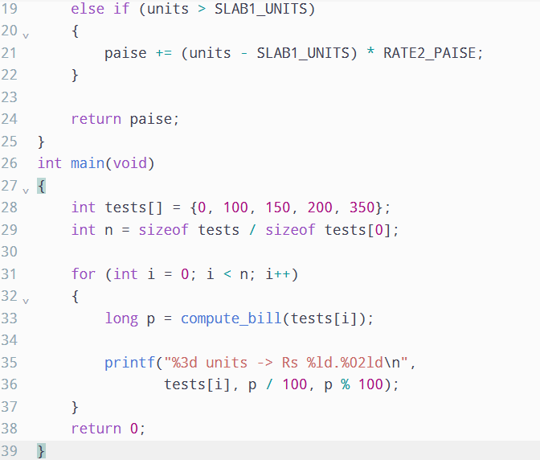
OUTPUT
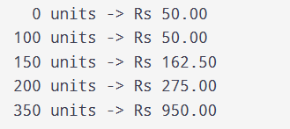

Tariff Revision - If the tariff rate changes from Rs. 2.25 to Rs. 2.30 per unit, only one macro needs to be modified.
ORIGINAL
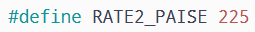
MODIFIED
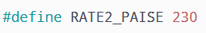
The updated rate will automatically be applied wherever the macro is used in the program.

Conclusion
Defining constants is important for maintaining accuracy and consistency in the electricity billing system. The #define directive is suitable for tariff rates and slab limits because it allows values to be changed in one place. const variables provide type checking, while enum is useful for representing categories. Therefore, using meaningful constants makes the program easier to understand, modify and maintain.

TASK 4

Introduction
- Macros are defined using the #define preprocessor directive in C. They are used to perform repeated calculations and simplify programs.
- In the electricity billing system, macros can be used for converting rupees into paise, finding the maximum of two values and calculating squares.
- Macros help reduce repeated code and improve readability. However, they must be written carefully to avoid unexpected results.
A function is a better choice when:
- The calculation is complex.
- Arguments contain increment or decrement operators.
- Type checking is required.
- Debugging is important.
- The same calculation is used many times.
Functions provide better safety and readability than macros in these situations.
SOURCE CODE
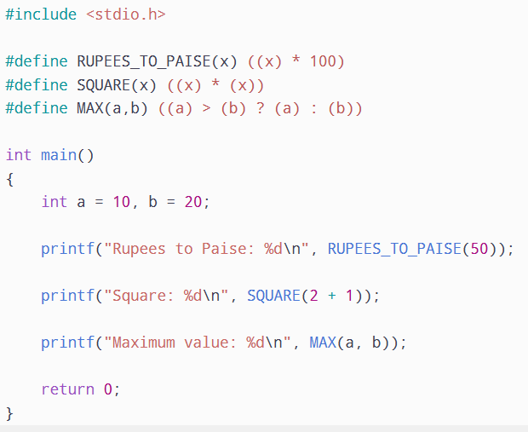
OUTPUT
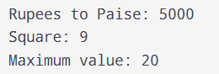

Conclusion
Macros are useful for performing repeated calculations and reducing code duplication in C programming. However, they must be written with proper parentheses to avoid operator-precedence errors. Macros such as SQUARE and MAX should be used carefully because they can evaluate arguments more than once. Static inline functions provide better type checking, readability and safety. Therefore, inline functions are preferable for complex calculations, while macros are suitable for simple repeated expressions.

TASK 5

Introduction
In C programming, header files are used to organise constants, macros and function declarations separately from the main program. The electricity billing system can be divided into different files to make the program easier to understand, maintain and modify. Conditional compilation allows us to include debugging statements only when required. This helps developers identify errors without affecting the normal execution of the program.

SOURCE CODE
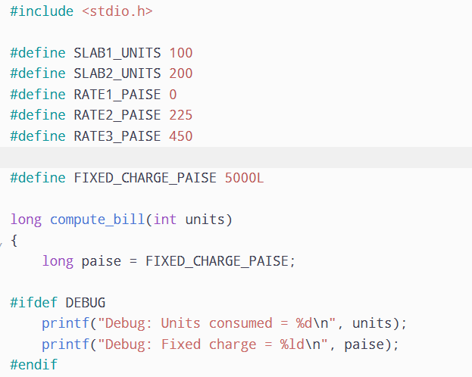
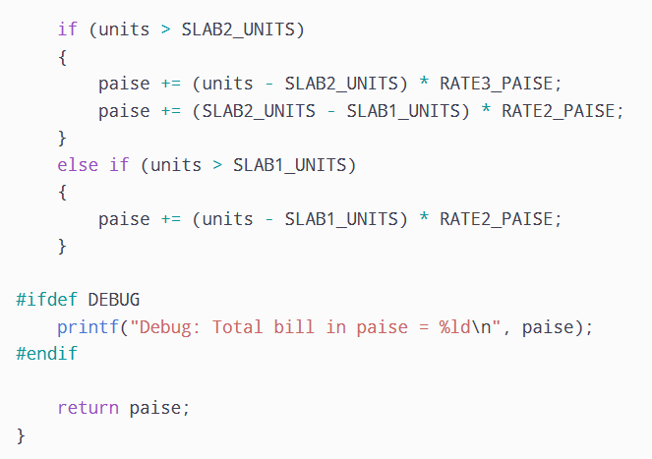
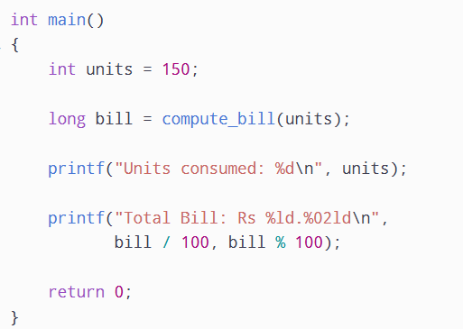

OUTPUT
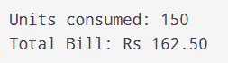

Conclusion
Header files help organise constants, macros and function declarations separately from the main program. Include guards prevent repeated inclusion of the same header file. Conditional compilation using #ifdef DEBUG allows debugging statements to be included only when required. This improves program organisation, reduces unnecessary code and makes the electricity billing system easier to maintain and modify.
TASK 6
Introduction
In a billing program, input data must be read correctly and output values must be displayed in the proper format. C provides format specifiers such as %d, %u, %f, and %ld to read and print different data types.
Using the wrong format specifier may produce incorrect results or undefined behaviour.
SOURCE CODE
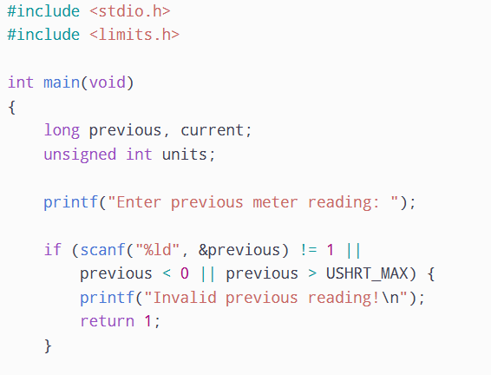
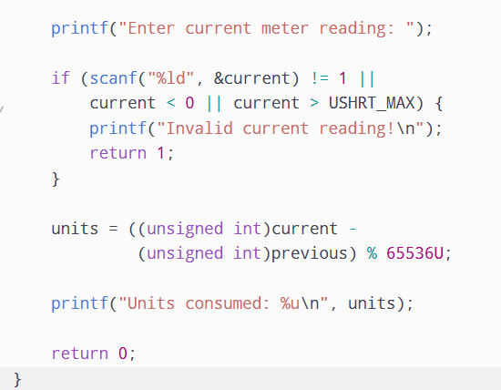
OUTPUT
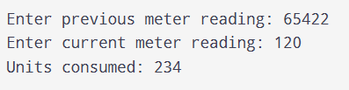
Conclusion
Correct input and output handling is important for building a reliable electricity billing program. Using proper format specifiers, checking the return value of scanf(), validating meter readings and displaying money in rupees and paise help prevent errors and improve program reliability.

TASK 7
Introduction
Type conversion in C is the process of converting a value from one data type to another. It helps perform calculations between different data types.
In an electricity billing system, proper type conversion is important to calculate electricity charges accurately and avoid precision errors.

SOURCE CODE
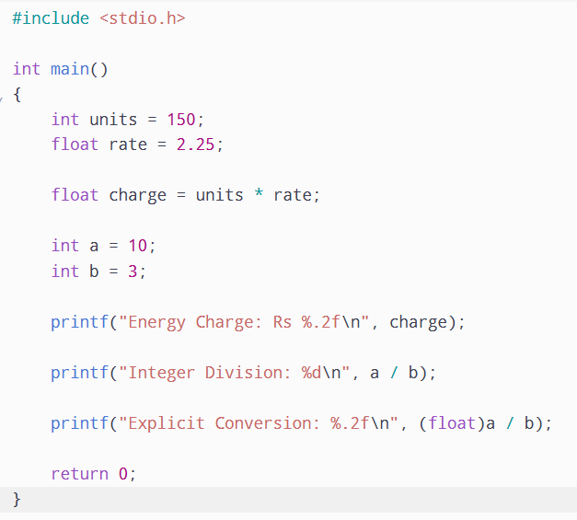

OUTPUT
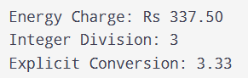
Conclusion
Type conversion plays an important role in C programming. Implicit and explicit conversions help perform calculations between different data types. Understanding integer division and floating-point precision helps prevent calculation errors. For the electricity billing system, storing money as integer paise is a reliable approach to maintaining accurate billing values.

TASK 8
Introduction
Compilation is the process of converting a C program into an executable program that a computer can run. A C program passes through different stages during compilation. Each stage performs a specific task and helps identify errors before execution.
Compiling a C Program Using GCC
The following commands demonstrate the compilation stages:
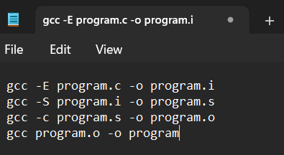

This command compiles and links both source files into one executable program.
Conclusion
Compilation is an important process in C programming. It consists of preprocessing, compilation, assembly and linking. Each stage converts the program into a different form until the final executable is generated. Understanding these stages helps programmers identify errors and develop reliable applications.

TASK 9
Aim: To implement a complete C billing program for the Grama Jyothi Rural Electricity Co-operative and test it using normal readings, boundary cases, meter rollover and invalid inputs.
PSEUDO CODE
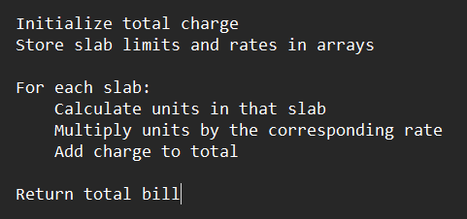

SOURCE CODE
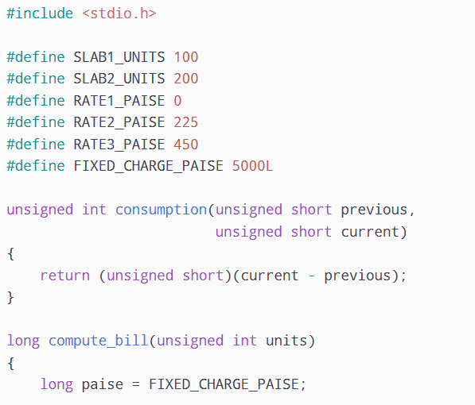
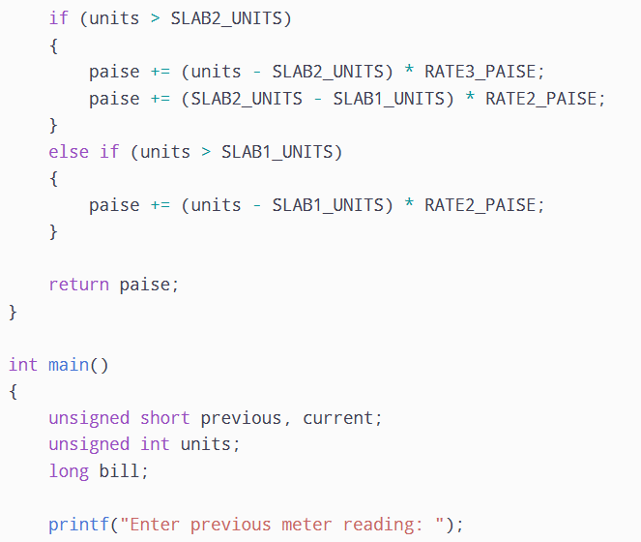
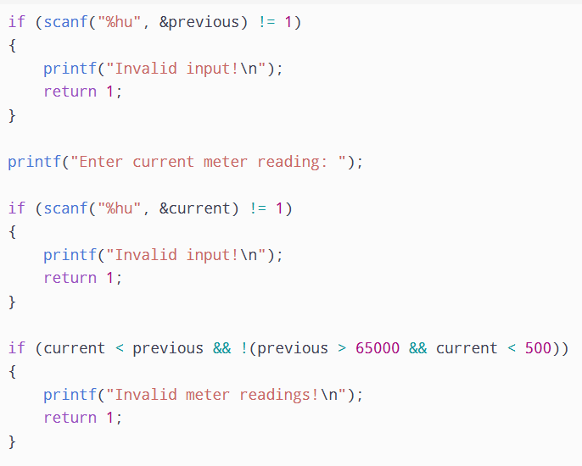
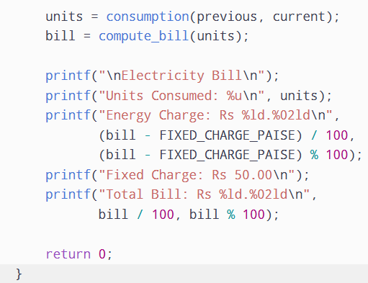

OUTPUT
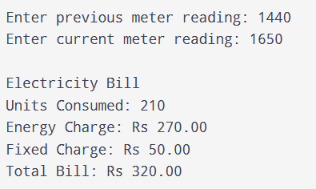

Conclusion: The fixed if-else method is suitable when the number of slabs is small and fixed. The array and loop method is easier to modify when new tariff slabs are introduced.

TASK 10
Aim: To compare the expected results of different data types with actual execution and analyse precision, overflow and memory usage in the electricity billing program.

SOURCE CODE (comparing float and integer paise)
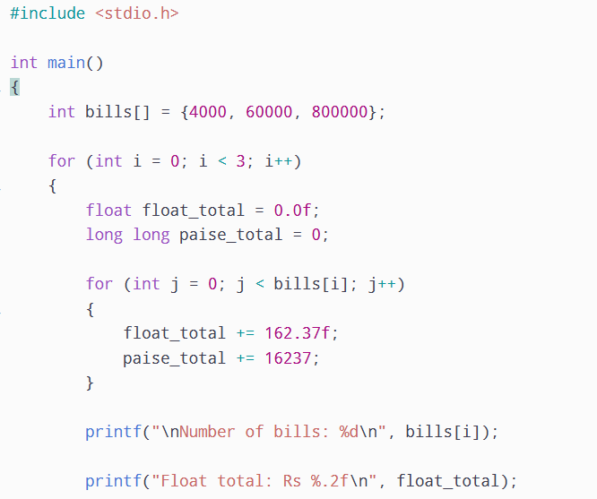
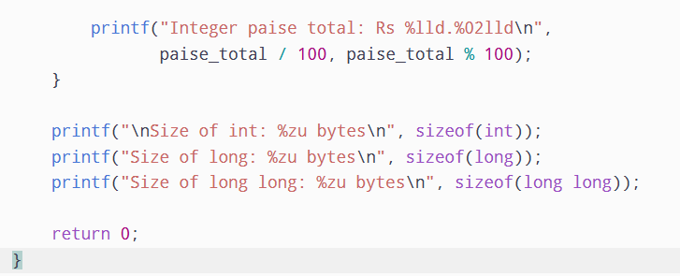
OUTPUT
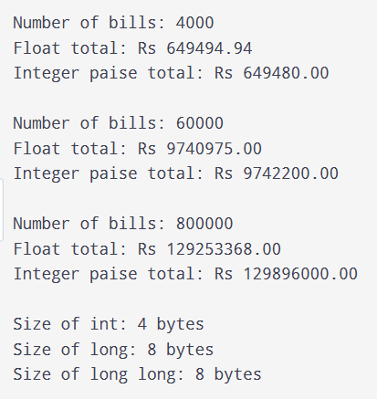
Conclusion
The experiment shows that floating-point calculations can produce precision errors when a large number of bills are added repeatedly. Integer paise provides exact monetary calculations and avoids rounding errors. A 32-bit integer is insufficient for storing the district-level total in paise. Therefore, long is the most suitable choice for accumulating the total electricity bill.

TASK 11
Aim: To recommend the most suitable data types, constants and preprocessor features for the Grama Jyothi Rural Electricity Co-operative and justify the design based on accuracy, performance and scalability.

Tariff Revision
The tariff values are defined using #define macros at the beginning of the program.
Example:
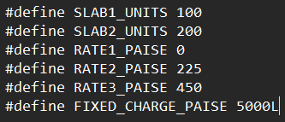
If the electricity tariff changes, the values can be updated in one place without modifying the billing calculation.
For example, changing RATE2_PAISE from 225 to 230 updates the second slab rate throughout the program.

Limitations of the Design
- The current design supports a fixed number of tariff slabs.
- Tariff changes require recompilation of the program.
- The original meter design supports only 16-bit readings.
- Fixed slab calculations are less flexible for time-of-day tariffs.
- Large-scale billing requires proper validation and error handling.

Suitability at District Scale
The co-operative may expand from 4,000 households to 8,00,000 households.
For this reason, long long is recommended for storing the total bill amount in paise.
For example:
4,000 households = Rs. 6,50,000
60,000 households = Rs. 97,50,000
8,00,000 households = Rs. 13,00,00,000
A 32-bit int cannot safely store the district-level total in paise. However, long long can store it without overflow.

Conclusion
The recommended design uses unsigned short for meter readings, unsigned int for units consumed, integer paise for individual bills and long long for district-level totals. Tariff values are maintained using well-named constants to avoid repeated changes in the program. This design provides accurate billing, reduces rounding errors and supports large-scale electricity billing. For future expansion, configuration files can be introduced to make tariff updates easier without recompiling the program

TASK 12
Aim: To re-evaluate the existing electricity billing system based on smart meter readings, time-of-day tariffs and runtime tariff updates, and develop an improved billing design.

A. Impact Analysis
The original billing system uses monthly meter readings and fixed tariff rates. The new requirement introduces smart meters that send readings in watt-hours every 15 minutes.
The major changes are:
- Smart meters generate 35,040 readings per household every year.
- Electricity consumption is measured in watt-hours instead of monthly units.
- Electricity consumed between 6 PM and 10 PM costs 20% more.
- Tariff values must be updated without recompiling the program.
- The system must process a large amount of data for 8,00,000 households.
Changes in data types:
- unsigned short is no longer suitable for storing yearly accumulated readings.
- unsigned long long is recommended for yearly watt-hour totals.
- long long is recommended for storing monetary values in paise.
- double can be used when calculating the 20% peak-hour charge, but the final amount should be rounded to integer paise.
Changes in constants:
The tariff rates should no longer be permanently defined using #define. Instead, they should be read from a configuration file when the program starts.

B. Evaluation of the Original Design
The original design is suitable for monthly billing but needs modifications for smart meter billing. The system must process approximately 28 billion readings per year.
Evaluation:
Original design | Evaluation
unsigned short | Insufficient for yearly accumulated readings
int | Insufficient for large yearly totals
long long | Suitable for large accumulated values
#define | Less flexible for tariff updates
Integer paise | Suitable for accurate money calculations
Fixed slab conditions | Need modification for peak-hour tariffs
Therefore, the original design should be modified to support larger readings, peak-hour calculations and runtime tariff configuration.
SOURCE CODE
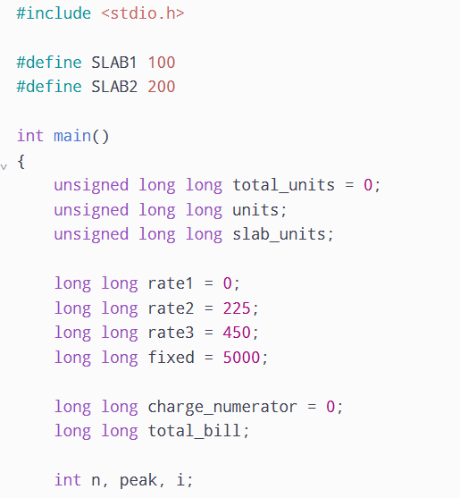
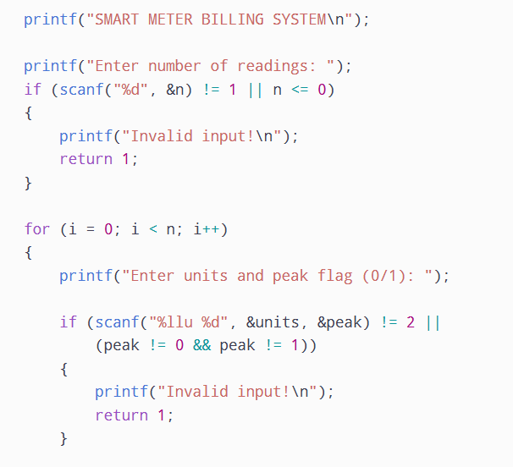
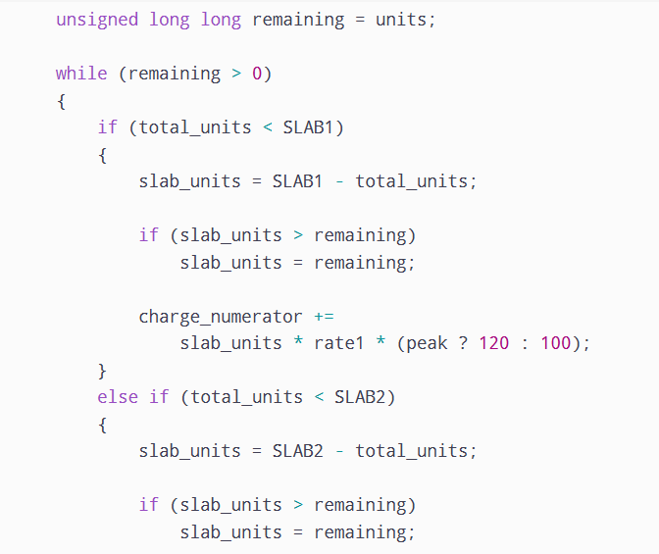
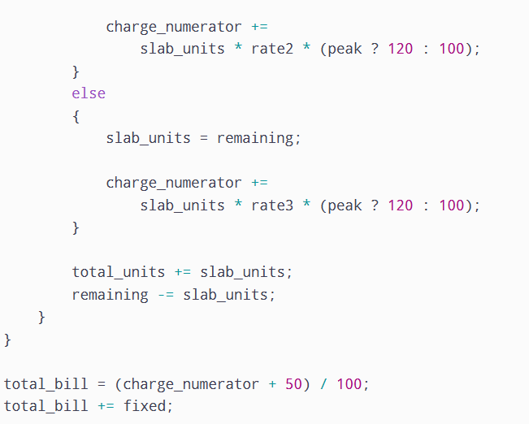

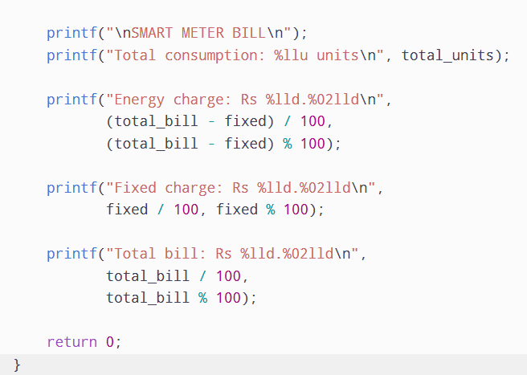

OUTPUT
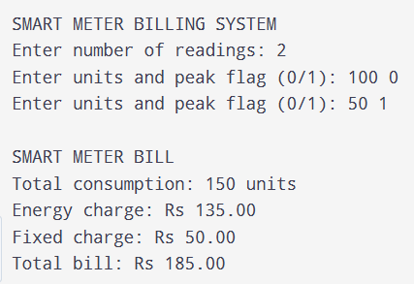

D. Evidence-Based Defence
The modified design is more suitable for the new smart meter requirements.
Reasons:
- unsigned long long supports large accumulated watt-hour readings.
- Integer paise avoids floating-point rounding errors in monetary calculations.
- Configuration files allow tariff changes without recompiling the program.
- The peak-hour rule correctly applies a 20% additional charge between 6 PM and 10 PM.
- Loop-based processing supports thousands of smart meter readings.

Conclusion
The original billing design should be modified rather than completely redesigned. The revised system uses wider integer data types, runtime tariff configuration, integer paise calculations and peak-hour tariff adjustments. These improvements provide accurate billing, flexibility and scalability for smart meter implementation. The modified design is suitable for future expansion of the Grama Jyothi Rural Electricity Co-operative.

